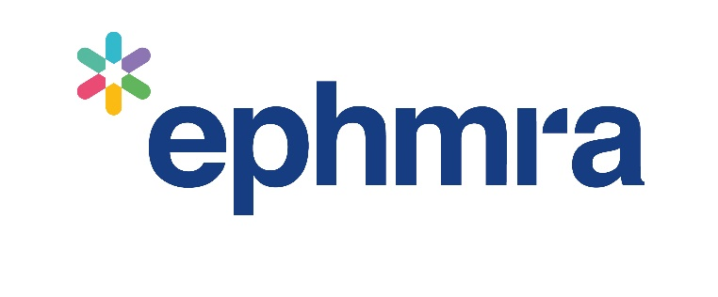

2024
EPHMRA
Code of Conduct Proformas

Pro Forma 1

Recruitment agreement
Project Details
Project Title: | Project No:
Nature of Project
Subject and purpose of market research study:

Methodology and Approach:

Fieldwork
Location: (if online or telephone, please state this) | Duration:
Date: | Start time:
Incentive
Type (e.g. cash): | Amount:
Respondent Signature
Signature: | Name (please print):
Respondent Code Number
Code Number:

Pro Forma 2

Receipt of Incentive
Project Details
Project Title: | Project No:
Agency: | Agency Contact:
Fieldwork
Date of receipt: | Start Time:
Location (If online or telephone, please state this): | Duration:
Incentive
Incentive Type (e.g. cash): | Incentive Amount:
Declaration
- I confirm that the information I have given during the course of this interview/group discussion represents my views on the subject matter.
- I confirm that I have received the incentive detailed above in appreciation for my contribution to the project.
Market Research Subject Signature
Signature: | Name (please print):
Market Research Subject Code Number
Code Number:

Pro Forma 3

Market Research Subject Consent Allowing Client Access to Market Research Fieldwork
Project Details
Project Title: | Project No:
Agency: | Location of Fieldwork:
Date of Fieldwork: | Start Time of Fieldwork:
Declaration
- I understand that the company that commissioned this Market Research study
(name of recipient organisation(s) may or may not be required will:
DELETE AS APPROPRIATE
- Watch through a one way mirror (watching organisations do not need to be named) but type of organisation(s) should be specified
- Listen to an audio recording at their offices (organisations listening in may or may not need to be named depending on whether audio information is considered personal data or not)
- Watch a video recording at their offices (watching organisation(s) must be named but naming may be delayed until the end of the interview if viewing is not live)
- I understand that the purpose(s) of the company having access is:
The people in the company who will listen to or view the recordings will be in the following functions/roles:
- I understand that all those listening, watching or viewing the recording MUST respect the confidentiality of all information exchanged in Market Research interviews/groups and that no sales approaches will ever be made to me as a consequence of the company having this access.
- I understand that I can withdraw my consent at any stage.
IF APPROPRIATE We would prefer not to reveal the name of the healthcare/pharmaceutical company until the end of the interview, just in case knowing this affects any responses. Is this acceptable to you or not?
- YES
- NO
Signatures
- I have read, understand and agree to the terms above.
Market Research Subject Signature: | Name (please print):
Agency Signature: | Name (please print):
Market Research Subject Code Number
Code Number:

Pro Forma 4

Client Agreement to Safeguard Confidentiality of Recordings of Market Research Fieldwork
Project Details
Project Title: | Project No:
Agency: | Location(s) of Fieldwork:
Date(s) of Fieldwork: | Start Time(s) of Fieldwork:
Commissioning Client Company:
Declaration
On behalf of <the commissioning client company> I can confirm that the recording(s) of Market Research fieldwork from the above study will only be used for the following purpose(s):
The only people in the company who will listen to or view the recordings will be in the following functions/roles:
And the recording(s) will be in the secure care of:
On behalf of the commissioning client I can confirm that:
Those listening to or viewing the recording will respect the confidentiality of all information exchanged in Market Research interviews/groups
- No sales approaches will ever be made to MR subjects as a consequence of having this access
- No attempt will be made to reverse any anonymization.
- The recordings will be stored securely, kept separate and processed in accordance with applicable data protection/privacy laws and Market Research professional codes.
- The recordings will be destroyed or handed back to the agency as soon as is required.
- If video streaming has been used to allow remote viewing it is possible that the video transmission system used delivered a copy of the recording to the receiving computer. If this is the case any copy of the video stream saved on the observer’s computer MUST be deleted.
Signatures
- I have read, understand and agree to the terms above
Company Signature: | Name (please print):
Agency Signature: | Name (please print):

Pro Forma 5

Observer Agreement
Project Details
Project Title: | Project No:
Agency: | Agency Contact:
Location of Fieldwork: | Date of Fieldwork:
 | Time of Fieldwork:
Declaration
- I understand that I MUST be familiar with and adhere to the EPHMRA’s Observers’ Guidelines.
Observer Signature
- I have read, understand and agree to the terms
Signature: | Name (please print):

Observers’ Guidelines
Client observers MUST be introduced openly and honestly to Market Research subjects. Actual company identity does not necessarily have to be revealed and if it does, it may be withheld until after fieldwork if this information is likely to bias the discussion.
Clients or their sub-contractors MUST NOT be passed off as members of the research agency.
Observers MUST agree to withdraw from observing if any Market Research subject is known to them or recognised to protect the Market Research subject’s anonymity. If an observer knows that they will subsequently have to deal with a Market Research subject, the attendee MUST also withdraw from observing. However, if Market Research subjects are made fully aware of the presence of an observer
known to them and give explicit consent for that individual to observe then that person may remain at the session, care should be taken that the Market Research subjects are completely comfortable if ‘put on the spot’ in this way.
Observers MUST respect the confidentiality of all information exchanged in Market Research interviews/ groups. They MUST NOT:
- Record any Market Research subject’s personal data or record any information with the specific aim of establishing the identity of a Market Research subject.
- Not make any separate identifiable notes or recordings that could be attributed to an individual Market Research subject.
- Attempt to influence how any Market Research subject is approached in future for sales/ promotion.
- Not use information gleaned from the observation to amend or build databases.

